Testing ssh of firewall,
Note: I use bastion host only
192.168.60.8 is permitted for ssh port only
I have acl in mls as well for vlan 60
so it blocks icmp request for vlan 60
port ssh is open for remote host
only necessary port is open as I want to make secure for management which has access to all vlan in internal network along with firewall remote access.
Now go to desktop of management vlan and in command line type
ssh -l prasanta 192.168.120.1
120.1 is interface of firewall connecting mls0
while I have done for both mls0 and mls1
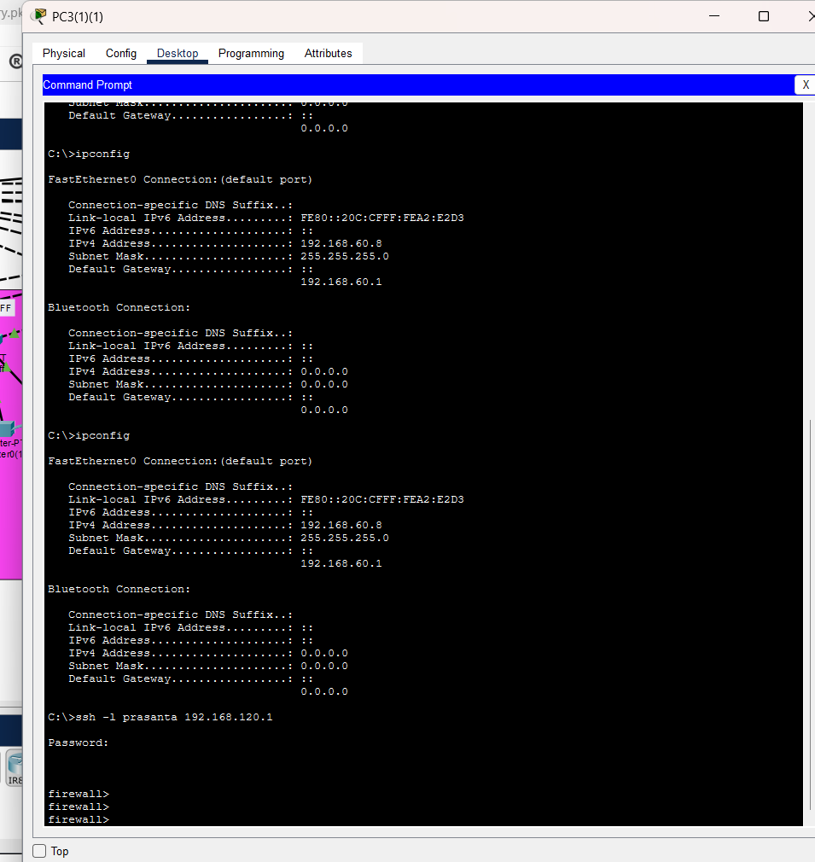
ssh -l prasanta 192.168.120.1
you can use
ssh -l prasanta 192.168.130.1
as I have done for mls0 and mls1
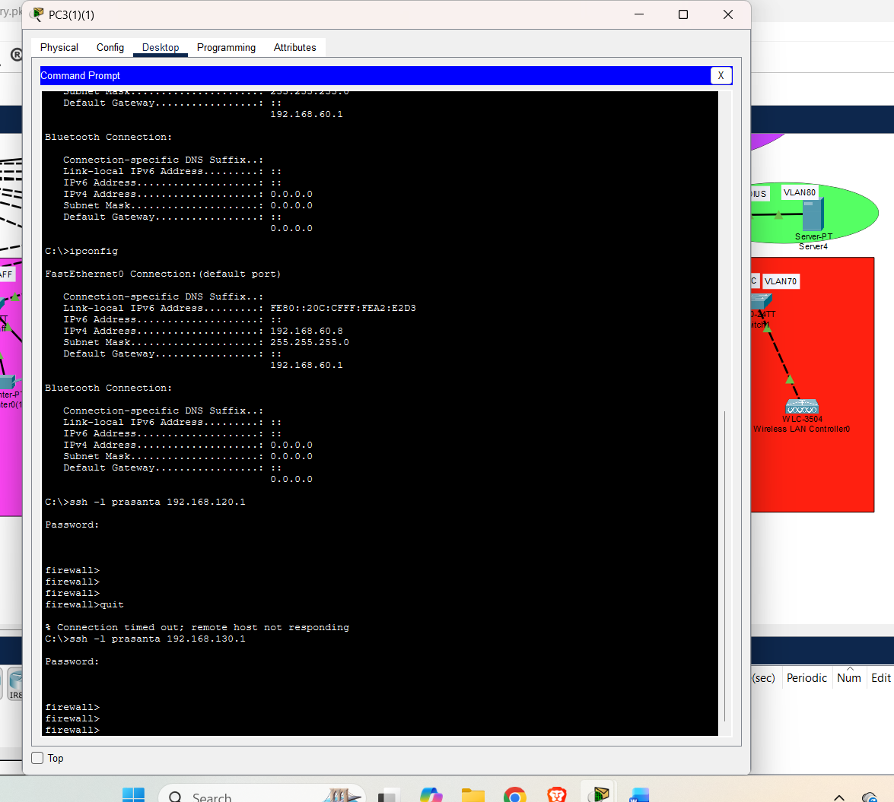
I wanted to show case radius authentication for failed to do it here especially firewall doesn’t support aaa server command so I have to do local
And for WIFI also I wanted to have radius authentication but have to do flexconnect and local authentication as wlc is buggy for dynamic interface I have multiple vlan setup with hsrp and ethernet channel .

